**E**stimation **A**nd **C**onfidence **I**ntervals

**Background**

In quality control processes, especially when dealing with high-value items, destructive sampling is a necessary but costly method to ensure product quality. The test to determine whether an item meets the quality standards destroys the item, leading to the requirement of small sample sizes due to cost constraints.

**Scenario**

A manufacturer of print-heads for personal computers is interested in estimating the mean durability of their print-heads in terms of the number of characters printed before failure. To assess this, the manufacturer conducts a study on a small sample of print-heads due to the destructive nature of the testing process.

**Data**

A total of 15 print-heads were randomly selected and tested until failure. The durability of each print-head (in millions of characters) was recorded as follows:

1.13, 1.55, 1.43, 0.92, 1.25, 1.36, 1.32, 0.85, 1.07, 1.48, 1.20, 1.33, 1.18, 1.22, 1.29

**Assignment Tasks**

**a. Build 99% Confidence Interval Using Sample Standard Deviation**

Assuming the sample is representative of the population, construct a 99% confidence interval for the mean number of characters printed before the print-head fails using the sample standard deviation. Explain the steps you take and the rationale behind using the t-distribution for this task.

**Solution:**

To build a 99% confidence interval for the durability of the print-heads using the sample standard deviation, we can follow these steps:

1. Calculate the sample mean x :
2. Calculate the sample standard deviation S :
3. Determine the degree of freedom (df): n-1
4. Find the critical value t* for a 99% confidence interval using the t-distribution:
5. Compute the margin of error (ME):
6. Calculate confidence interval:

Given data: 1.13, 1.55, 1.43, 0.92, 1.25, 1.36, 1.32, 0.85, 1.07, 1.48, 1.20, 1.33, 1.18, 1.22, 1.29

Let’s proceed with the calculations:

**Step1: Calculate the Sample mean x**

X = (1.13+1.55+1.43+0.92+1.25+1.36+1.32+0.85+1.07+1.48+1.20+1.33+1.18+1.22+1.29) / 15

**Step2: Calculate the Sample Standard Deviation s:**

s = ∑ni=1(xi-x)2

√ (n-1)

​​**Step3: Degrees of freedom (df):**

df = n-1

df = 15-1

df = 14

**Step4: Find the critical value t* for a 99% confidence interval using the t-distribution:**

We loop up t* for df = 14 and a confidence level 99%.

**Step5: Compute the margin of error (ME):**

ME = t* × (s/√n)

**Step6: Calculate the confidence interval:**

CI = (x - ME, x + ME )

**Calculating these values using python**

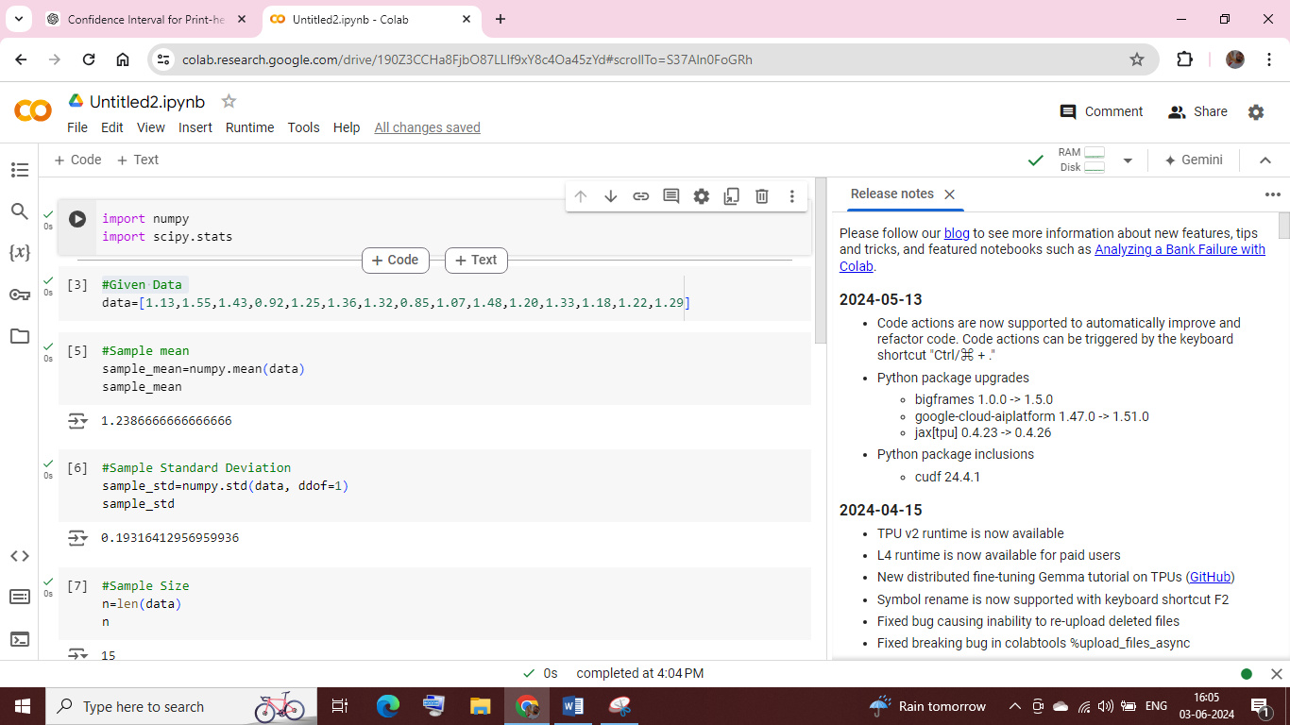

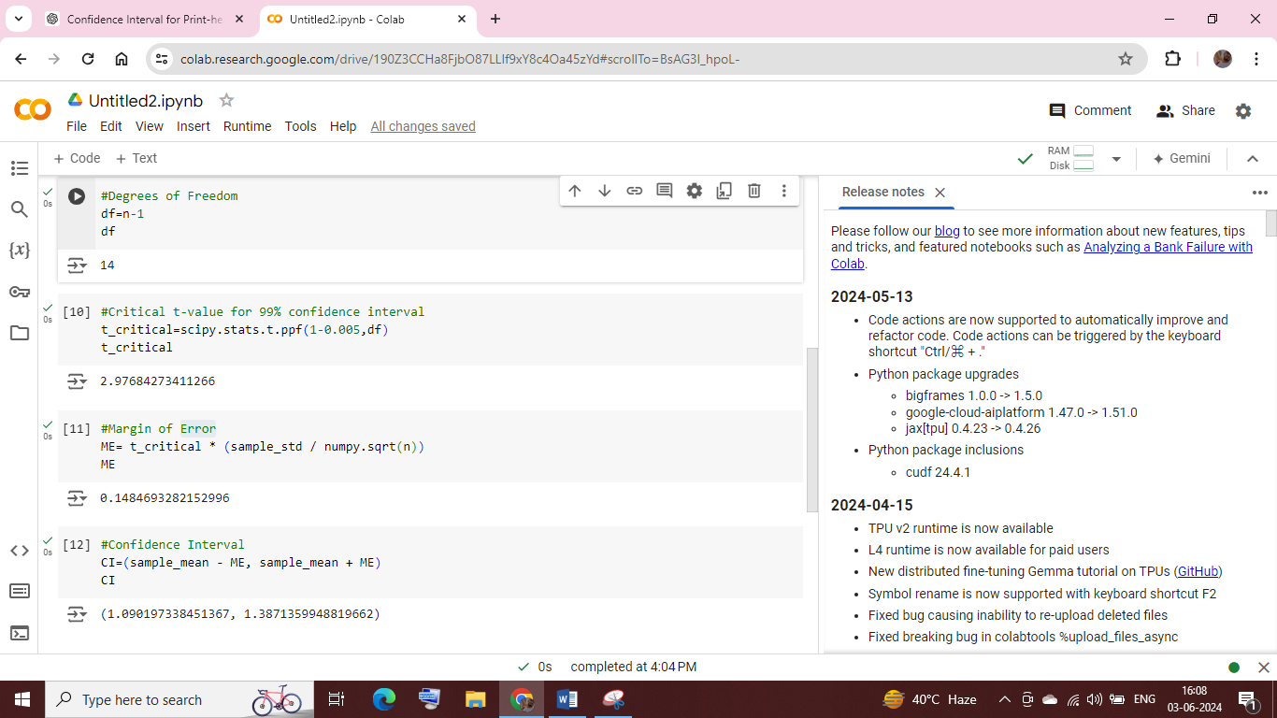

The calculations for the 99% confidence interval for the durability of the print-heads are as follows:

1. **Sample mean x:** 1.2387 (rounded to four decimal places)
2. **Sample Standard Deviation s:** 0.1932 (rounded to four decimal places)
3. **Degrees of freedom (df):** 14
4. **Critical t-value t*:** 2.9768 (rounded to four decimal places)
5. **Margin of error (ME):** 0.1485 (rounded of four decimal places)

**99% Confidence Interval:**

**(x – ME, x + ME) = (1.2387 – 0.1485, 1.2387 + 0.1485)**

**CI = (1.0902, 1.3872)**

Therefore, the 99% confidence interval for the durability of the print heads is

(1.0902, 1.3872) million characters.

**b. Build 99% Confidence Interval Using Known Population Standard Deviation**

If it were known that the population standard deviation is 0.2 million characters, construct a 99% confidence interval for the mean number of characters printed before failure.

**Solution:**

To construct a 99% confidence interval for the mean number of characters printed before failure,

Given that the population standard deviation is known, we use the formula for the confidence interval of mean with a known standard deviation:

x ± Z(𝜎/√n)

Where,

* x is the sample mean
* Z is the Z-score corresponding to the desired confidence level (for99% confidence, Z is approximately 2.576)
* 𝜎 is the population standard deviation
* N is the sample size

Given data:

* Population standard deviation, 𝜎 =0.2
* Sample size=15
* Sample data = 1.13, 1.55, 1.43, 0.92, 1.25, 1.36, 1.32, 0.85, 1.07, 1.48, 1.20, 1.33, 1.18, 1.22, 1.29

First, we calculate the sample mean (x):

x = ∑ni=1xi

n

Calculating x and then use it to find the confidence interval.

The sample mean (x) is approximately 1.2387 million characters.

Using the given population standard deviation of 0.2 million characters and a Z-score of 2.576 for a 99% confidence level

Calculate the standard error of mean (SEM) = 0.2 / √15 = 0.05165

Calculate the margin of error (MOE) =2.576 × 0.05165 = 0.133

Construct the confidence Interval = (1.2387 – 0.133, 1.2387 + 0.133)

CI = (1.1057, 1.3717)

So, the 99% confidence interval for the mean number of characters printed before failure is approximately: (1.106, 1.372) million characters.

Thus, we can be 99% confident that the true mean durability of the print-heads lies within this interval.